Noel A. Schweig, M.D.

March 22, 1930 – June 1, 2012
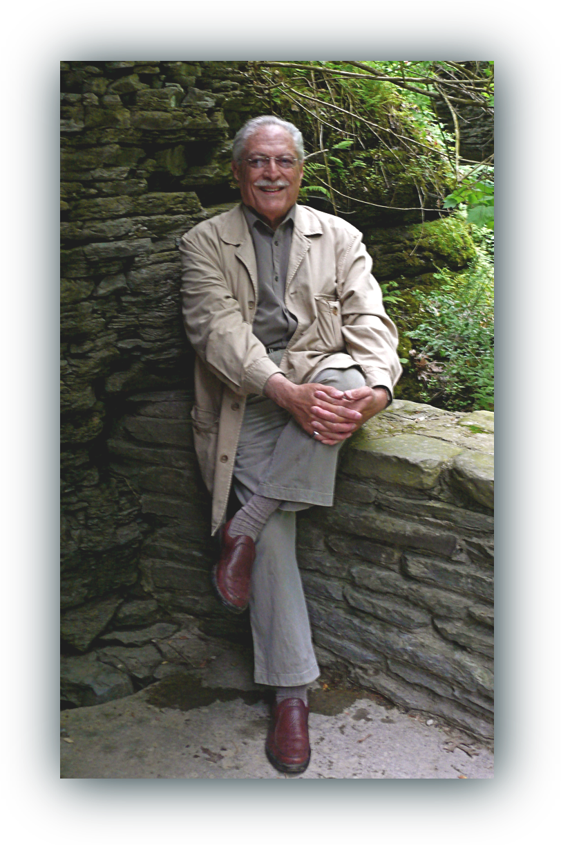

Noel A. Schweig, psychiatrist and psychoanalyst, died on Friday, June l, 2012 at home in Nellysford, VA. In addition to his parents, Joel Schweig and Sidonia Gelles, who emigrated from Vienna in the early 1900s, he was preceded in death by his sister, Stephanie Barach.

He attended The Columbia Grammar School in New York, and graduated from Wesleyan University. He studied medicine at Utrecht University in the Netherlands and graduated from Duke University Medical School in 1956. He spent one year in a rotating medical internship at the Long Island Jewish Hospital, and then moved to Washington, DC with his wife at the time and two children.

His post-graduate work in psychiatry was divided between St. Elizabeth’s Hospital and George Washington University Medical Center. Following two years as a fellow in the National Institute of Mental Health, he established a private practice and began ten years of psychoanalytic training. He ultimately became a faculty member and teaching analyst with the Washington Psychoanalytic Institute and was associate professor of psychiatry at the George Washington University Medical School.

For over five decades, he practiced psychiatry and psychotherapy where he remained committed to a psychoanalytic orientation even as the psychiatric profession itself turned increasingly to psychopharmacology. In 1988, he established a second office in Middleburg, VA. In 2006, he moved to the Charlottesville, VA area where he maintained an active practice until his death.

He was an avid Photographer for his entire adult life and pursued it vigorously around the world. His work was displayed in shows and galleries and can be viewed on his website, noelschweig.com.

Dr. Schweig was previously married to Nannette Hertz and Dallal Richards.

He is survived by his wife of 25 years, Lois A. Vitt, his children, Graham M. Schweig and Gwen A. Seidlitz, his stepchildren John Alan Vitt, Michael Vitt, Ginny Plumeau, Lois Vitt Sale, Elle Vitt and Pati Vitt, eleven grandchildren, and three great grandchildren.

A Memorial Service will be held at the Thomas Jefferson Memorial Church, 717 Rugby Road, Charlottesville, VA 22903 on Saturday, June 16, 2012 at 11:00am.

In lieu of flowers, donations are requested for the Noel A. Schweig Memorial Internship Fund at the Institute for Socio-Financial Studies (ISFS.org), 325 Four Leaf Lane, Suite 7, Charlottesville, VA 22903. Dr. Schweig supported over a dozen internships at ISFS since its founding in 1991. He strongly believed in, and practiced, furthering the extraordinary possibilities inherent in each individual.

